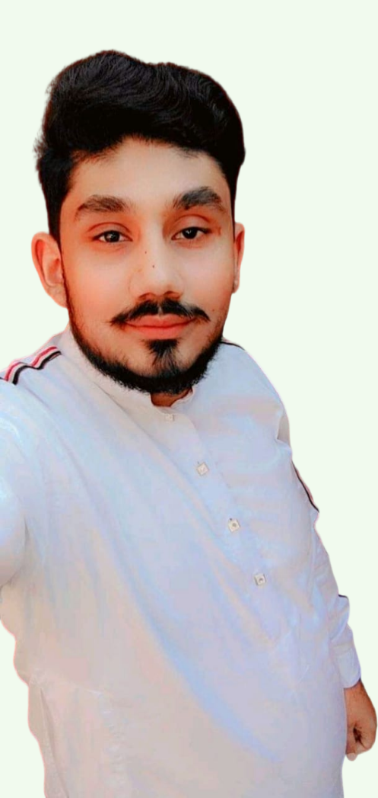

***Web developer***

PNY, LAHORE

SEP 2022 - NOV 2022

***COMPOSER***

PAK FOUNDATION, LAHORE

APRIL 2022 – Present

***COMPUTER TEACHER***

PAK ANGEL ACADMEY, LAHORE

SEP 2021 - Present

***EDUCATION***

* ***Diploma in software technology***

PNY Arfa Tower, LAHORE

MAY 2022 - continue

* ***ICS***

Shalimar College, LAHORE

2016

***EXPERIENCE***

Self-motivated team player seeking lead web developer employment with Next Generation Web Development where I can utilize my advanced knowledge of web design and my management skills to satisfy customer needs and exceed their expectations.

***SUMMARY***

**M UMAN ILYAS**

* Cricket
* Reading Quotes

***HOBBIES***

* ENGLISH
* URDU
* PUNJABI

***LANGUAGES***

***SKILL HIGHLIGHTS***

* HTML
* CSS
* JAVASCRIPT
* PHP
* MYSQL

***SKILL HIGHLIGHTS***

Daroghawala, Lahore, Pakistan

mumanilyas271@gmail.com

+923020405262